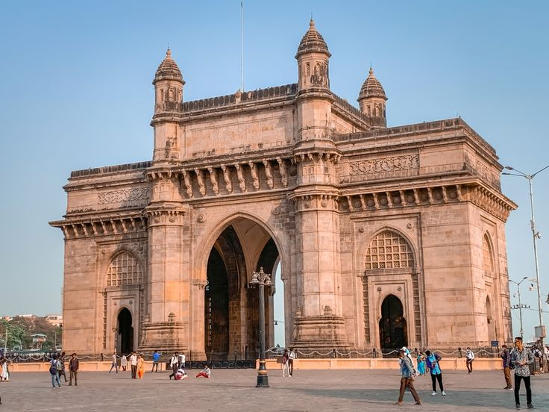
GEMS OF INDIA

Circuit: Mumbai – Cochin – Munnar – Periyar – Kumarakom – Varanasi – Ayodhya – Delhi – Agra – Jaipur – Jaisalmer – Jodhpur – Udaipur – Ahmedabad – Vadodra – Mumbai
ITINERARY:
DAY 01: | 12 NOV’26 | ARRIVAL MUMBAI – 01 PAX
Meeting and assistance upon arrival at Mumbai International Airport and transfer to the hotel. Upon arrival, check in at the hotel in Mumbai.

Overnight stay at hotel in Mumbai

DAY 01: | 13 NOV’26 | ARRIVAL MUMBAI – 04 PAX
Meeting and assistance upon arrival at Mumbai International Airport and transfer to the hotel.

Vehicle at disposal

Overnight stay at hotel in Mumbai
DAY 02: | 14 NOV’26 | MUMBAI
Vehicle at disposal

Overnight stay at hotel in Mumbai.
DAY 03: | 15 NOV’26| MUMBAI

Vehicle at disposal

Overnight stay at hotel in Mumbai.

DAY 04: | 16 NOV’26| MUMBAI – COCHIN (AI 2855: 1000HRS / 1205HRS)
Morning after breakfast drive to Mumbai Airport to board flight for Cochin. Meeting and assistance upon arrival at Cochin International Airport and transfer to hotel in Cochin.

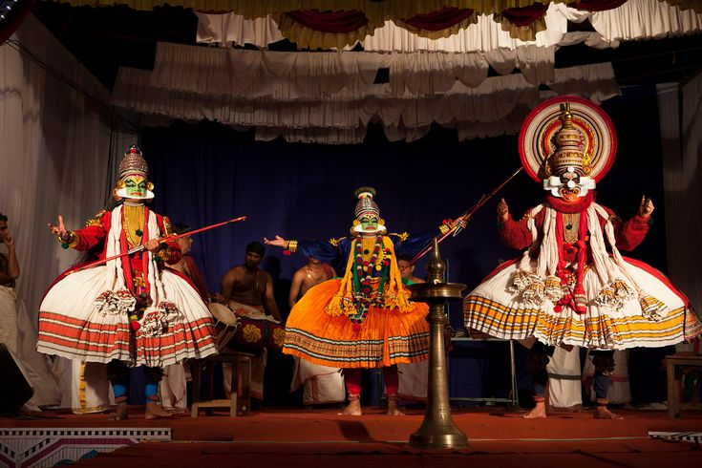
Evening enjoy Kathakali performance: Literally meaning "story dance" is the pantomimic dance drama, the dancing and the acting being blended together into an inseparable form. It is a combination of facial expressions and body movements, which brings out the thought and emotion of the character. Kathakali is predominantly a male art and the dancing is mostly of the masculine type. The position taken by the actor is angular. He never stands erect while acting, his knees being spread out and his legs forming a rhombus, his hands bent at the elbow and his palms on his hips. The outer feet are never flat on the ground and still the actor maintains a perfect balance. The female character is lasya which is gentle and grateful. This is particularly evident in love scenes

Overnight stay at hotel in Cochin.

DAY 05: | 17 NOV’26| COCHIN – MUNAR (126KM, 03HRS)
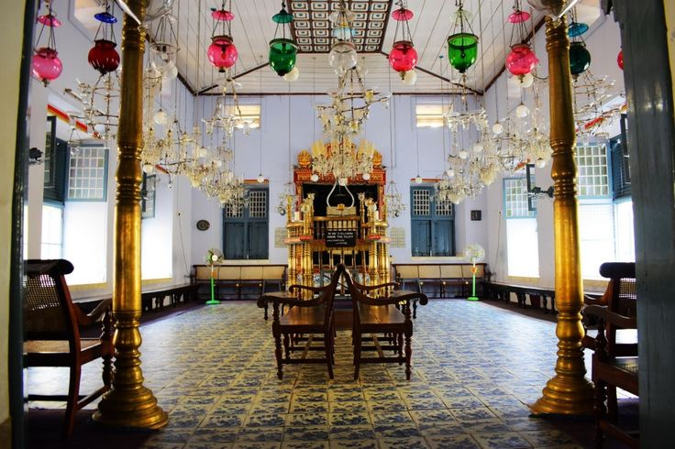
Morning after breakfast proceed for sightseeing tour of Cochin visiting the Dutch Palace, which has some of India’s most beautiful murals, the Jewish Synagogue in the heart of Jew Town and the cantilevered Chinese fishing nets. See St. Francis Church where Vasco da Gama was originally buried, and the Santa Cruz Church with its pastel coloured interior and carved wooden panels. Also visit Mattancherry Palace.

Afternoon free for shopping

Overnight stay at hotel in Munnar
DAY 06: | 18 NOV’26| MUNNAR
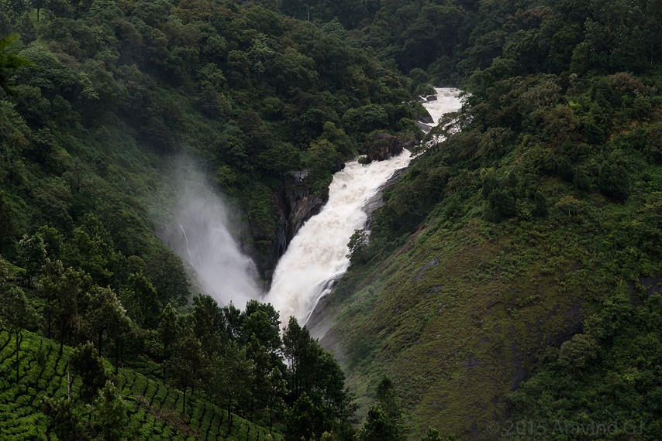
Morning after breakfast, proceed for a sightseeing tour of Munar, visiting Attukad Waterfalls: Resembling a delicate thread of pearls cascading from a great height, the waterfall is a breathtaking spectacle. Framed by rolling slopes and vibrant greenery, it offers an idyllic setting for photography enthusiasts. Access to the falls involves crossing a narrow wooden bridge, often veiled in mist, adding a touch of mystery to the journey. The surrounding area is rich in rare species of flora and fauna, making it a delight for nature lovers. Visitors may choose to trek deeper into the jungle or enjoy a leisurely walk through the tranquil landscape. The ideal time to visit is just after the monsoon season, when the waterfall reveals its freshest and most enchanting natural beauty.

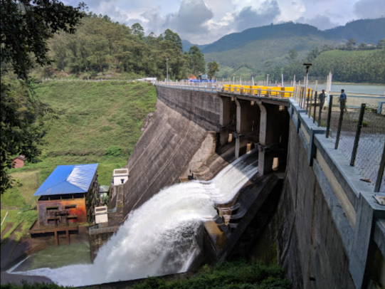
Mattupetty Dam and Lake – Tranquility Amidst the Hills: Located about 13 km from Munnar, Mattupetty Dam and Lake is a serene and scenic destination set amidst rolling hills, lush tea plantations, and dense evergreen forests. Built as part of a hydroelectric project, the dam has over the years evolved into one of Munnar’s most popular sightseeing attractions, admired for its calm waters and picturesque surroundings. The expansive Mattupetty Lake, formed by the dam, reflects the surrounding hills and drifting clouds, creating a postcard-perfect landscape. The area is well known for boating experiences, including speedboats and paddle boats, allowing visitors to soak in the beauty of the tranquil environment at a relaxed pace.

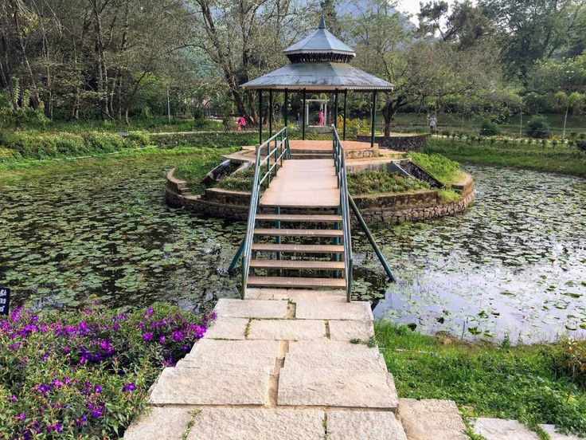
Blossom Park: Located near the heart of Munnar town, Blossom Park—also known as Blossom Hydel Park—is a beautifully landscaped garden offering a peaceful escape amidst lush greenery and cool mountain air. Spread along the banks of the River Muthirapuzha, the park is an ideal spot for relaxation, light recreation, and leisurely walks. The park is adorned with well-maintained lawns, vibrant flower beds, and towering trees, creating a soothing natural ambiance. Visitors can enjoy gentle strolls along paved pathways, admire the colorful seasonal blooms, or simply unwind while soaking in the serene surroundings. Activities such as cycling, boating, and nature walks add a touch of recreation, making it suitable for families and leisure travelers.

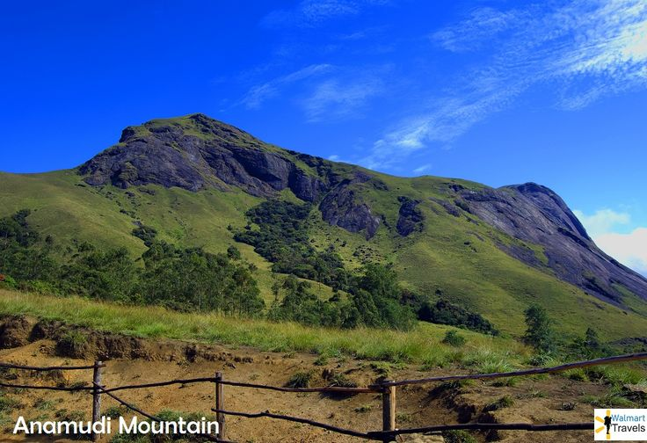
Anamudi Peak: Rising to an elevation of 2,695 metres, Anamudi Peak is the crowning glory of Eravikulam National Park and the highest peak in South India. Located within the majestic Nilgiri mountain range, the region is characterized by dense evergreen forests dominated by bamboo and teak, and is home to a rich variety of rare and exotic flora and fauna. The peak offers breathtaking panoramic views of rolling tea and spice plantations, mist-filled valleys, and undulating hills. Its serene environment makes it an ideal place to spend quality time with family, friends, or a partner amidst nature. While trekking, hiking, and wildlife safaris remain popular activities for adventure enthusiasts, the area also serves as a delightful spot for peaceful picnics and quiet contemplation, allowing visitors to experience the untouched beauty of the Western Ghats.

Overnight stay at Munar hotel.
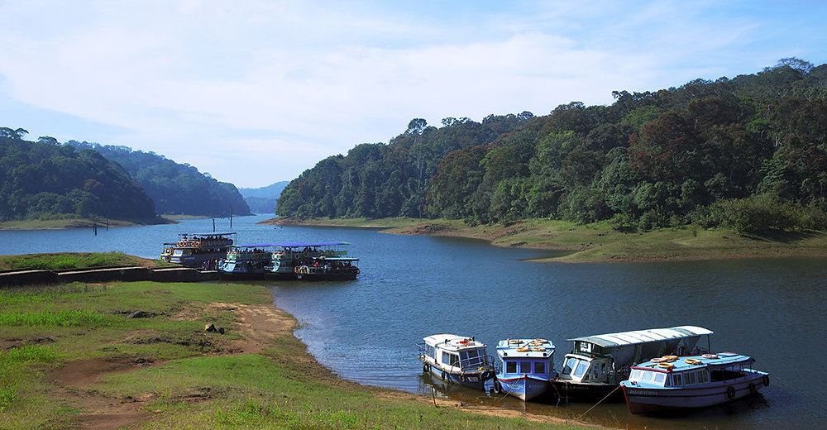
DAY 07: | 19 NOV’26| MUNAR – PERIYAR (96KMS, 03HRS)
Morning after breakfast drive to Periyar. Upon arrival check in at hotel in Periyar. Afternoon proceed for boat ride on Lake Periyar , and see the wildlife around the lake as you cruise along its banks. Apart from elephants, bison, sambar, wild boar, langur, otter and flying squirrel are common. There are also 246 species of birds and 112 species of butterfly.

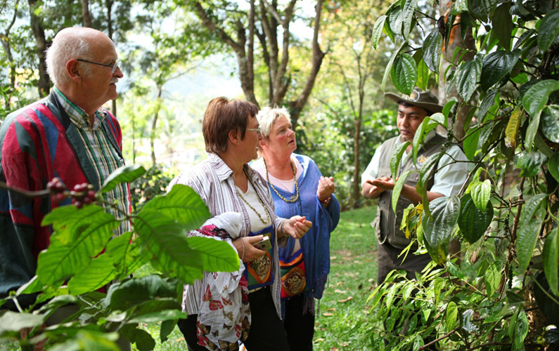
Later proceed for Spice Plantation Tour – A Fragrant Journey Through Nature
A Spice Plantation Tour offers a refreshing and immersive experience into the aromatic world of Kerala’s famed spices. Set amidst lush greenery and gently sloping hills, these plantations showcase the cultivation of spices that have shaped the region’s history and global trade for centuries. During a guided walk through the plantation, visitors are introduced to a variety of spices such as cardamom, pepper, cinnamon, cloves, nutmeg, vanilla, and ginger, growing naturally under the shade of towering trees. Knowledgeable guides explain the planting methods, medicinal properties, and traditional uses of each spice, providing valuable insight into Kerala’s rich agricultural heritage

Overnight stay at hotel in Periyar.
DAY 08: | 20 NOV’26| PERIYAR – KUMARAKOM (130KMS, 04HRS)
Early Morning proceed for Nature walk (0700Hrs 1000Hrs). After walk back to hotel for freshnup, breakfast. Check out from the hotel and drive to Kumarakom.

Afternoon enjoy one hour backwater cruise .

Rest of the day free for relaxation.

Overnight stay at hotel in Kumarakom.

DAY 09: | 21 NOV’26| KUMARAKOM – COCHIN (83KMS, 02HRS) – VARANASI (6E 951: 1340HRS/1515HRS & 6E 6719: 1640HRS/1830HRS – VIA HYDERABAD)
Morning after breakfast drive to Cochin Airport to board flight for Varanasi. Meeting and assistance upon arrival at Varanasi Airport and transfer to hotel in Varanasi.

Overnight stay at hotel in Varanasi

DAY 10: | 22 NOV’26| VARANASI
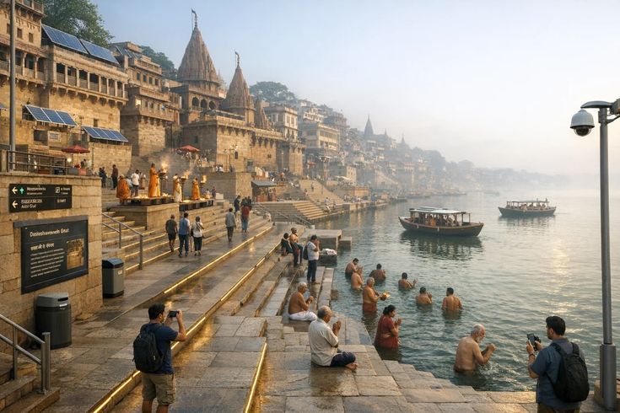
Take an early morning boat ride on the river Ganges to see the bathing ghats and cremation sites. You can see pilgrims bathing and performing rituals on the Ghats, one of the most extraordinary experiences of a visit to India. Sunrise on the riverfront, as seen from a boat, can be a spiritually uplifting sight. Later see the Viswanath temple (also called Golden Temple due to its gold plated towers) dedicated to Shiva. Non-Hindus not allowed inside.
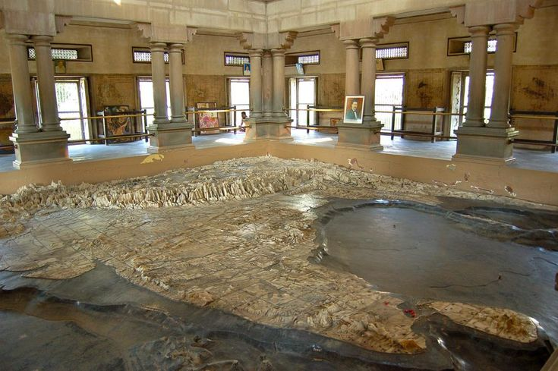
After boat ride return to hotel for breakfast and freshn up. Later in the Morning proceed for
sightseeing tour of Varanasi visiting the Bharat Mata temple with its big marble relief map of India, the Durga temple and the modern marble Tulsi Manas temple whose walls are engraved with scenes and verses from the Ramcharitmanas, the Hindi version of the Ramayana. Also see the New Viswanath temple, one of the tallest in India (non Hindus are not allowed inside the temple). Go around the Benares Hindu University and its museum, and see the mosque of the Mughal Emperor Aurangzeb.

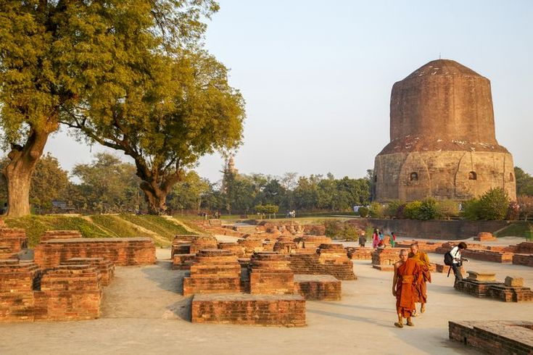
Afternoon Take a tour of the Sarnath ruins, dominated by the Dhamekh Stupa supposedly marking the point where Buddha delivered his sermon. See the ruins of the monasteries and the remains of the Ashoka Pillar which once stood over 20m high. Also visit the Sarnath Museum displaying finds from the site, including the famous lion capital from the Ashoka Pillar.

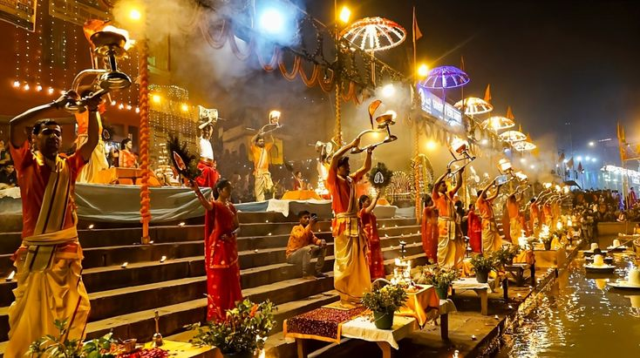
Evening proceed to wittness Ganga Aarti at Varanasi – A Timeless Spiritual Spectacle: As dusk descends upon the ancient city of Varanasi, the sacred ghats along the River Ganges transform into a stage for one of India’s most profound spiritual rituals—the Ganga Aarti. Performed every evening at the iconic Dashashwamedh Ghat, this centuries-old ceremony is a majestic expression of devotion, gratitude, and reverence to Maa Ganga, revered as both a life-giver and a divine mother.
At the precise moment twilight merges with darkness, young priests clad in traditional silk attire take their designated positions on raised platforms facing the river. The air resonates with the rhythmic chants of Vedic hymns, the gentle clang of bells, and the hypnotic cadence of conch shells. As the ritual unfolds, large multi-tiered brass lamps are ceremoniously lit and moved in perfectly synchronized motions, creating arcs of fire that illuminate the riverfront and reflect gracefully on the flowing waters of the Ganges.

Overnight stay at Varanasi hotel
DAY 11: | 23 NOV’26| VARANASI – AYODHYA (219KMS, 04HRS)
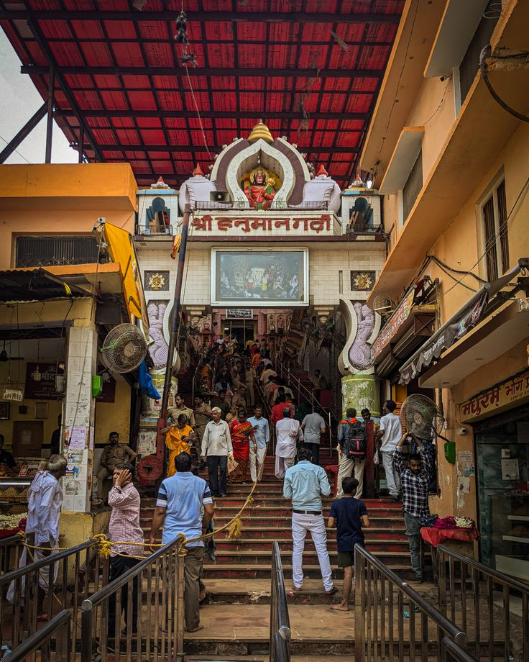
Morning after breakfast drive to Ayodhya. Upon arrival check in at hotel in Ayodhya. Afternoon proceed for shot visit of Hanuman Garhi – The Sacred Sentinel of Ayodhya: Perched atop a small hill in the revered city of Ayodhya, Hanuman Garhi stands as one of the most significant and beloved temples dedicated to Lord Hanuman. Revered as the divine guardian of Ayodhya, this ancient shrine is believed to have been established to honor Lord Hanuman’s role as the protector of Lord Rama’s birthplace and kingdom. Accessed by a flight of steps leading to the sanctum, the temple complex exudes an atmosphere of devotion and quiet strength. At its heart lies a sacred cave-like sanctum housing a rare and deeply revered idol of Lord Hanuman seated in a royal posture, accompanied by his mother Anjani. This unique representation symbolizes Hanuman not only as a mighty warrior but also as a devoted son and eternal servant of Lord Rama.

Overnight stay at Ayodhya hotel.

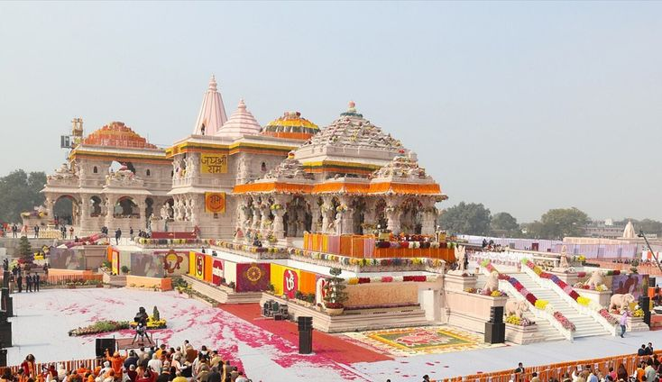
DAY 12: | 24 NOV’26| AYODHYA – DELHI (6E 6436: 1400HRS/1525HRS)
Morning after early breakfast visit Shri Ram Janmabhoomi Mandir – The Spiritual Heart of Ayodhya: The Shri Ram Janmabhoomi Mandir in Ayodhya stands as a monumental symbol of faith, devotion, and India’s timeless civilizational heritage. Built at the sacred site believed to be the birthplace of Lord Rama, the temple represents the fulfillment of centuries-old spiritual aspiration and occupies a central place in the hearts of millions of devotees across the world. Designed in the classical Nagara style of temple architecture, the Ram Mandir reflects the grandeur of ancient Indian craftsmanship. Constructed using intricately carved sandstone, the temple showcases majestic pillars, sculpted panels, and finely detailed motifs depicting scenes from the Ramayana, divine deities, and sacred symbols. Every element of the structure has been meticulously planned to align with traditional Vastu and Shilpa Shastra principles, lending the temple both architectural harmony and spiritual sanctity.

Later drive to Ayodhya airport to board flight for Delhi. Meeting and assistance upon arrival at Delhi airport and transfer to hotel in Delhi.

Overnight stay hotel in Delhi

DAY 13: | 25 NOV’26| DELHI
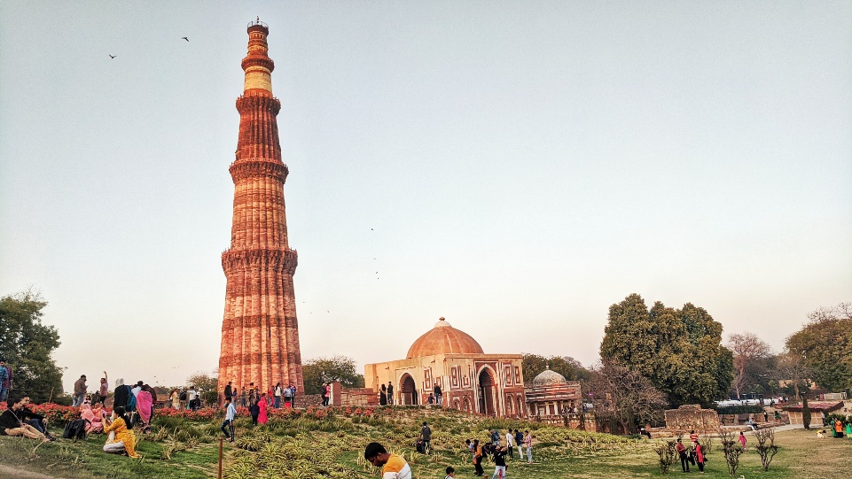
Morning after breakfast proceed for sightseeing tour of Delhi visiting New Delhi is built in a typically British colonial style with tree-lined avenues and colonial bungalows. See the Laxminarayan Temple, a modern Hindu temple, and India Gate, the 42 m high War Memorial Arch. Drive past the Parliament House, the Secretariat buildings and the Vice Regal Palace, now the official residence of the President of India. You will also visit Qutab Minar – what was intended to be the most glorious tower of victory in the world and was to be the prototype of all minars in India. Then, go down to Old Delhi to visit the 17th century Jama Masjid, the largest mosque in India. See Chandni Chowk, the shopping center of old Delhi and drive past the Red Fort for a photo stop. Visit Raj Ghat where Mahatma Gandhi was cremated.

Evening enjoy sound and light show at Red Fort in the evening starting at 2030Hrs.

Overnight stay at hotel in Delhi

DAY 14: | 26 NOV’26| DELHI – AGRA (232KMS, 04HRS)
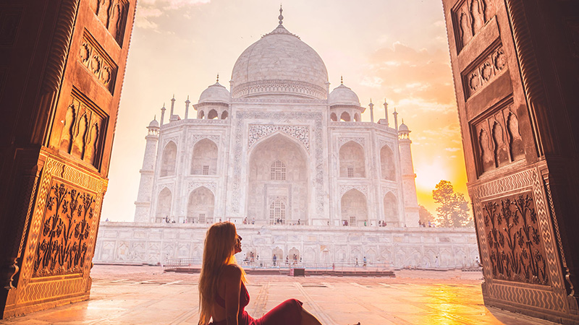
Morning after breakfast drive to Agra. Upon arrival check in at hotel in Agra. Afternoon proceed for sightseeing tour of Agra visiting Taj Mahal: Shahjahan, who was a passionate builder, now decided to erect a memorial marble that the world would never forget. The site was also chosen because it was located on a bend in the river, and so could be seen from Shahjahan's personal palace in Agra Fort, further upstream. The construction of the Taj Mahal started in 1631. It took 20,000 artisans 22 years to complete this poignant mauseoleum that blends subtlety with grandeur, and a massive overall design with immaculately intricate execution.

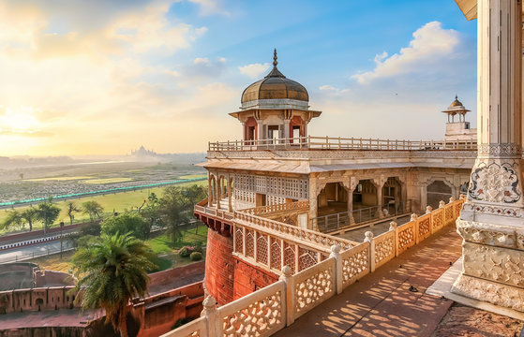
Agra Fort: The construction of the Agra Fort was begun by Emperor Akbar in 1565. Its massive walls stretch for 2½ km and are surrounded by a moat over 10 metres wide. The fort is really a city within a city, which embraces the Moti Masjid, the Diwan-i-Am or the Hall of Public Audiences, the Diwan-i-Khas or the Hall of Private Audiences, the Octagonal Tower, Jehangir’s Palace and many more monuments.

Overnight stay at hotel in Agra

DAY 15: | 27 NOV’26| AGRA – JAIPUR (232KMS, 04HRS)
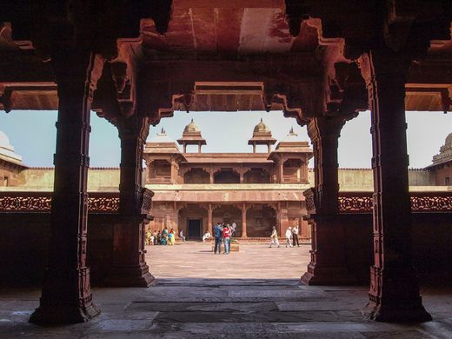
Morning after breakfast drive to Agra enroot visiting Fatehpur Sikri: The magnificent fortified ghost city of Fatehpur Sikri was built by Emperor Akbar in 1569 as his capital and abandoned 15 years later, allegedly due to a severe scarcity of water. You will visit the graceful buildings within such as the Jami Masjid, the tomb of Salim Chisti, the Panch Mahal, Diwan I Khas and other palaces. It is a place where Islamic architecture fuses with Hindu and Jain decorative art.

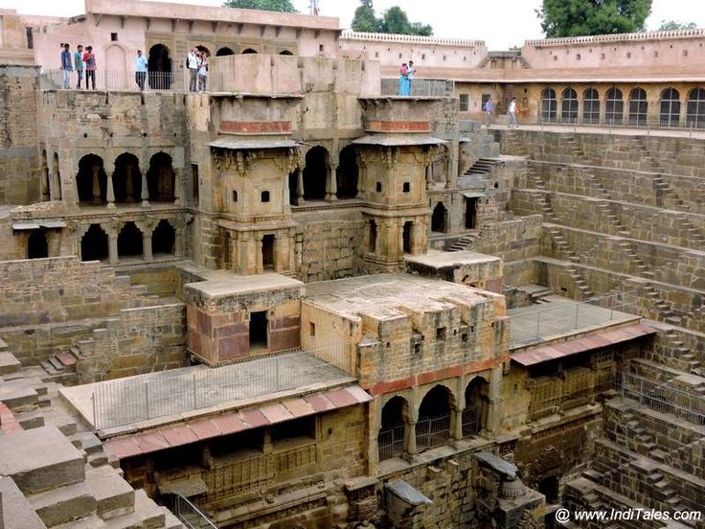
Chand Baori (Abhaneri): Chand Baori is said to be named after a local ruler of Nikumbh dynasty called Raja Chanda. However, no epigraphic evidence has been found regarding the construction of the Chand Baori or the adjoining Harshat Mata Temple. Based on similarities in style and carvings with the terraced temples of Paranagar and Mandore, the Baori can be dated to the 8th-9th century. It was likely constructed before the temple. According to Morna Livingston in Steps to Water: The Ancient Stepwells of India, Chand Baori is one of the few stepwells that has "two classical periods of water building in a single setting"

Continue drive to Jaipur. Upon arrival check in at hotel in Jaipur.

Overnight stay at hotel in Jaipur

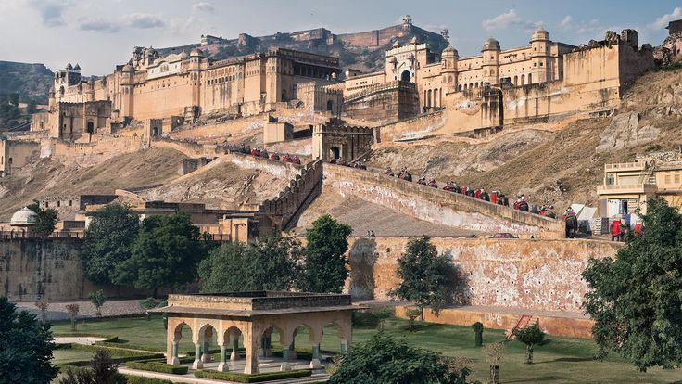
DAY 16: | 28 NOV’26| JAIPUR
Morning Visit the ancient Rajput capital of Amber Fort with elephant ride, 11 km from the city. This fort-palace was begun by Raja Man Singh and used by the Rajputs as their stronghold until Sawai Jai Singh II moved to the newly created Jaipur. See the Diwan I Am or hall of public audience, Kali temple, Jai Mandir or hall of victory with its inlaid panels and mirror ceiling, and Sukh Niwas. The fort provides breathtaking views of the lake below.

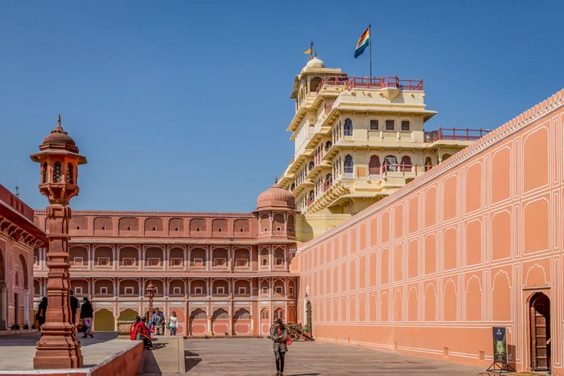
Afternoon proceed for sightseeing tour of Jaipur visiting visiting the Maharaja’s City Palace and the Jantar Mantar Observatory. Jaipur’s walled City Palace (1732 AD) occupies one-seventh of the city’s area. See the Mubarak Mahal, museums of textiles and armoury etc, and the Diwan I Khas and Diwan I Am. Jantar Mantar, literally meaning “instruments for measuring the harmony of the heavens” is the oldest in India. Each instrument has a specific purpose and gives an accurate reading. Photo stop at Hawa Mahal (Palace of the Winds). Also, drive past the rose-pink residential and business areas of Jaipur.

Enjoy dinner at Samode Palace experiencing the Rasjathani culture cusine.

Overnight stay at hotel in Jaipur

DAY 17: | 29 NOV’26| JAIPUR – JAISALMER (6E 7675: 0920HRS : 1105HRS)
Morning after breakfast drive to Jaipur airport to board flight for Jaisalmer. Meeting and assistance upon arrival and transfer to hotel. Upon arrival check in at Camp in Jaisalmer.

Afternoon enjoy camel ride at Dunes.

Dinner & overnight stay at camp in Jaisalmer.

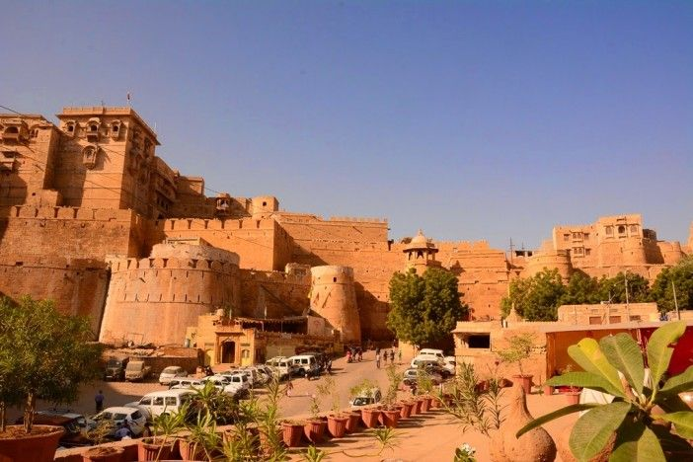
DAY 18: | 30 NOV’26| JAISALMER
Morning after breakfast proceed for sightseeing tour of Jaisalmer visiting the fort built by Rawal Jaisal atop the 80 m high Trikuta hill, where a fourth of the population still lives. Within the fort are also beautifully carved Jain temples of the 12th to the 15th centuries. See Badal Vilas Palace, the former ruler’s 20th century palace. Also visit some impressive merchant mansions (havelis) including Patwon ki Haveli (1805), a five-storey building with carved pillars and murals, Salim Singh and Nathmalji ki Haveli.

Afternoon free for shopping / visit local market

Overnight stay at Jaisalmer hotel.

DAY 19: | 01 DEC’26| JAISALMER – JODHPUR (272KMS, 04HRS)
Morning after breakfast drive to Jodhpur. Upon arrival check in at hotel in Jodhpur.

Rest of the day free for relaxation / explore surroundings.

Overnight stay at hotel in Jodhpur

DAY 20: | 02 DEC’26| JODHPUR
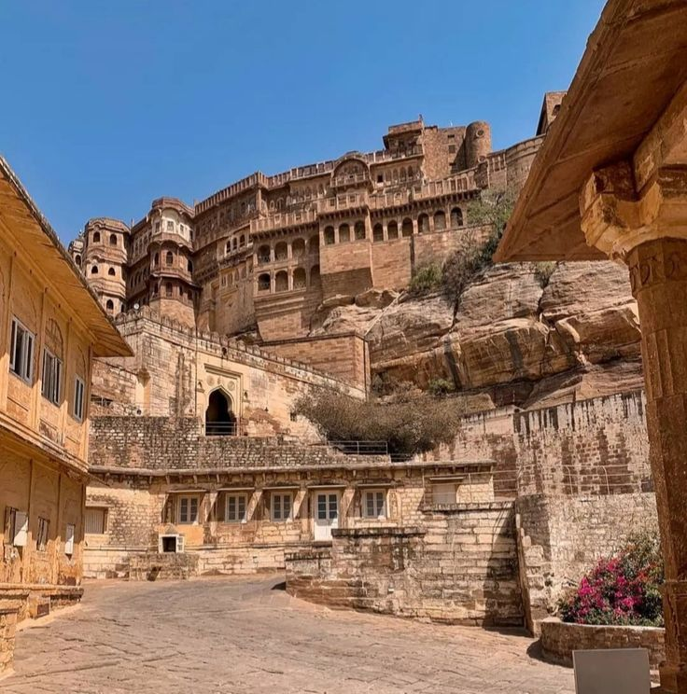
Morning after breakfast proceed for sightseeing tour of Jodhpur visiting Meherangarh Fort, Rising dramatically from a sheer rocky hill above the blue city of Jodhpur, Mehrangarh Fort stands as one of India’s most magnificent and imposing forts. Built in 1459 by Rao Jodha, the founder of Jodhpur, this formidable citadel dominates the skyline and serves as a powerful symbol of Rajput valor, architectural brilliance, and royal grandeur. Within the fort lies an extraordinary complex of palaces adorned with intricately carved stone latticework (jalis), expansive courtyards, ornate balconies, and richly decorated interiors. Highlights include the Moti Mahal (Pearl Palace), Phool Mahal (Flower Palace), Sheesh Mahal, and Takht Vilas, each reflecting the opulence and refined tastes of the Rathore rulers. The fort’s museum houses an exceptional collection of royal artifacts, including palanquins, arms, costumes, paintings, and musical instruments, offering deep insight into the regal lifestyle of Marwar.

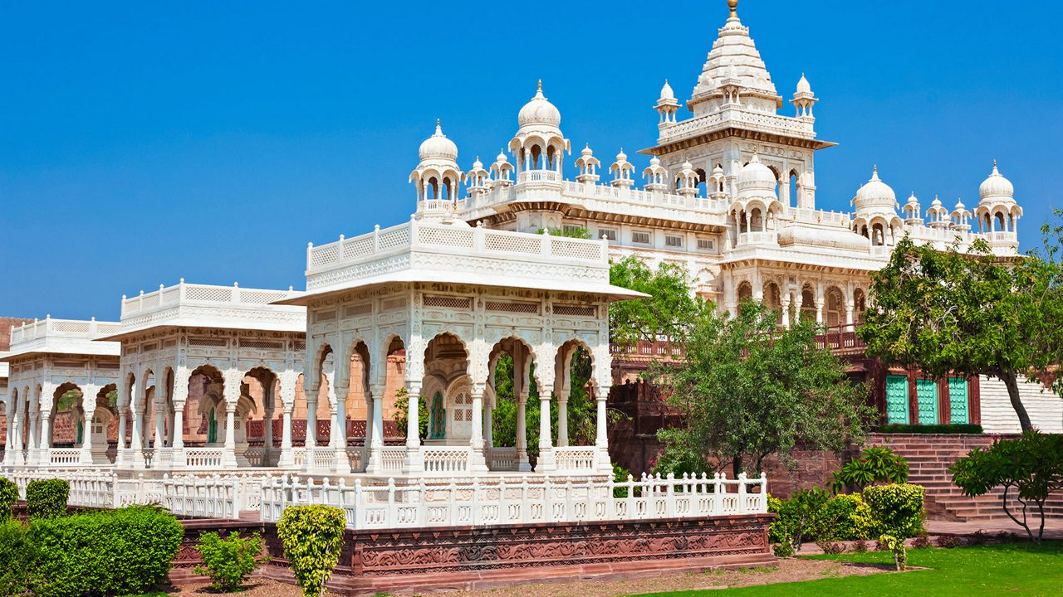
See the Jaswant Thada: Set against the dramatic backdrop of Mehrangarh Fort and overlooking a serene lake, Jaswant Thada is an exquisite marble cenotaph and one of Jodhpur’s most elegant and tranquil landmarks. Built in 1899 by Maharaja Sardar Singh in memory of his father, Maharaja Jaswant Singh II, this architectural gem serves as the royal cremation ground of the Rathore rulers of Marwar. Constructed from finely polished white marble, Jaswant Thada is renowned for its delicate latticework, intricately carved pillars, and domed chhatris that glow softly in sunlight, earning it the poetic title of the “Taj Mahal of Marwar.” The marble sheets used in its construction are so thin and finely crafted that they emit a warm, ethereal glow when illuminated by the sun.

Afternoon free for relaxation / exploring the surroundings

Overnight stay at hotel in Jodhpur

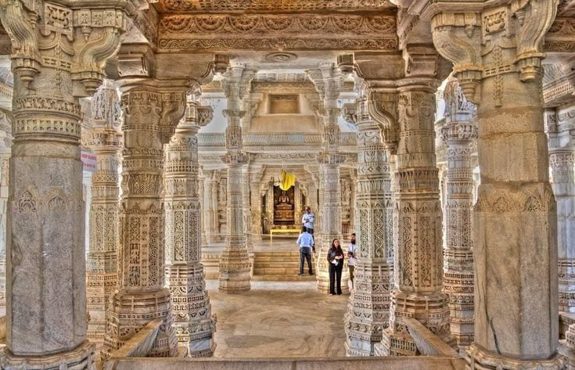
DAY 21: | 03 DEC’26| JODHPUR – UDAIPUR (260KMS, 05HRS 5MNTS)
Morning after drive to Udaipur enroot visiting Ranakpur: The largest Jain temple complex in India and dates to the 15th century. The main temple is dedicated to Adinath, the first Tirthankar. Intricate carvings detail mythological figures, patterns and motifs on the walls, pillars and domes. There are 1444 ornately carved marble pillars in the complex and none of them are similar. The beautiful lace-like interiors of the domes are a superb example of western Indian temple style. Surya temple and other Jain temples are side attractions. (Temples open only at 1200 Hrs. Leather belts, footwear, bare legs and black clothing not allowed)

Continue drive to Udaipur. Upon arrival check in at hotel in Udaipur.

Overnight stay at hotel in Udaipur

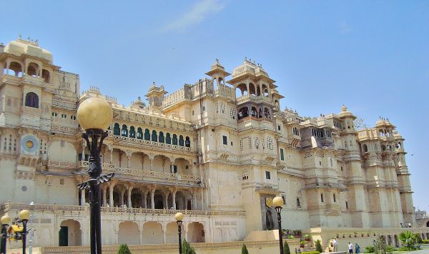
DAY 22: | 04 DEC’26| UDAIPUR
Morning after breakfast proceed for sightseeing tour of Udaipur visiting City Palace and Museum. The largest palace complex in India, it is a blend of Mughal and Rajput influences. Also see the 17th century Jagdish temple, drive around the Fatehsagar Lake, and visit the Sahelion ki Bari (the Garden for the Maids of Honour), an ornamental pleasure garden with fountains and marble kiosks. Later visit the Bharatiya Lok Kala Mandir or the Folk Art Museum.

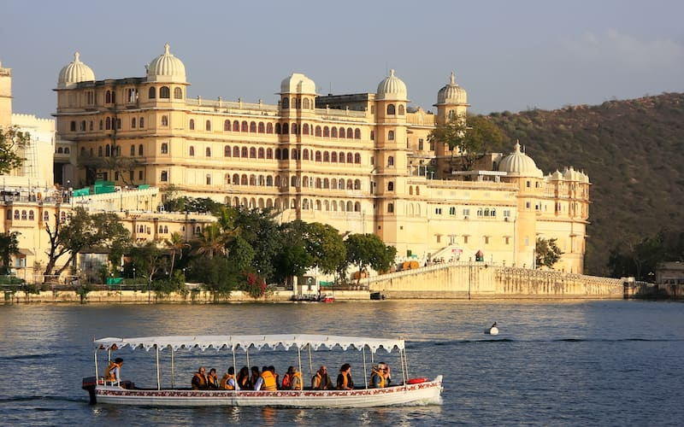
Afternoon Take a boat ride on the 4 km long and 3 km wide Lake Pichola, which is fringed with hills, palaces, havelis, ghats, embankments and temples and offers spectacular views of the city. Visit the Jag Mandir Island with its exquisite Gul Mahal Pavilion.

Overnight stay at hotel in Udaipur

03 PAX DEPARTING FOR MUMBAI
DAY 23: | 05 DEC’26| UDAIPUR – MUMBAI (AI 2580: 1155HRS / 1330HRS)
Morning after breakfast drive to airport to board flight for Mumbai. Meeting and assistance upon arrival at Mumbai airport and transfer to hotel. Upon arrival check in at hotel in Mumbai.

Overnight stay at hotel in Mumbai

DAY 24: | 06 DEC’26| DEPART MUMBAI
On time transfer to Mumbai international Airport to board flight for onward destation.

02 PAX CONTIUE TOUR
DAY 23: | 05 DEC’26| UDAIPUR – AHEDABAD (257KMS, 04HRS)
Morning after breakfast drive to Ahmedabad. Upon arrival check in at hotel in Ahmedabad.

Rest of the day free for relaxation / explore surrounding

Overnight stay at hotel in Ahmedabad

DAY 24: | 06 DEC’26| AHEDABAD (257KMS, 04HRS)
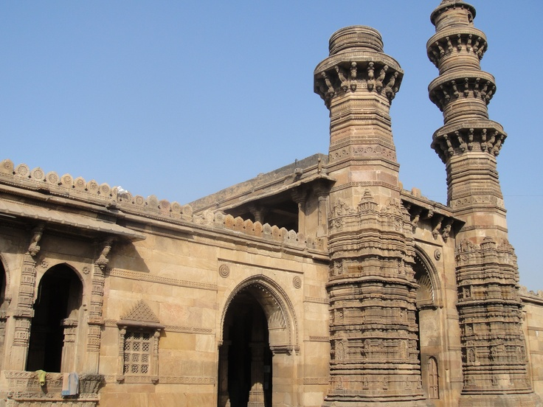
Morning after breakfast proceed for sightseeing tour of Ahmedabad visiting the 16th century Sidi
Sayid mosque famous for its wonderful stone tracery and the beautiful Jami Masjid, one of the
best examples of Gujarat’s Islamic architecture. See the 16th century white marble Hathi Singh Jain temple which is a good example of Hindu and Islamic design, the Dada Hari Baoli (step-well), and the shaking minarets of Sidi Bashir mosque. Later pay a visit to the Calico Textile Museum and Gandhi’s Sabarmati Ashram, the starting point for the celebrated Salt March of 1930.

Rest of the day free for relaxation / explore surrounding

Overnight stay at hotel in Ahmedabad

DAY 25: | 07 DEC’26| AHEDABAD – VADODRA (120KMS, 02HRS)
Morning after breakfast drive to Vadodra exroo visiting Nadiad: It is believed that the area was originally inhabited by rope dancers known as the Natas, from whom the city derived its earliest name, Natapadra or Natpur. Over time, the settlement was also referred to as Nandgram, and through gradual linguistic evolution, the name eventually transformed into Nadiad. According to local tradition, the earliest settlement of the city was located near Pilvai Lake, close to the Bhairav Temple. In its formative years, Nadiad witnessed the rule of various dynasties and powers, including Muslim rulers and the Gaekwad dynasty, before coming under British administration during the period of British India. There has long been scholarly debate regarding the exact antiquity of Nadiad. Some historians believe that as early as 585–586 Samvat, the area existed as a small village, though no definitive written records are available to substantiate this claim. It is widely accepted that this early settlement was known as Pilvai, around which a suburb inhabited by the Nat community developed. This suburb, then called Natpur, gradually expanded westwards, eventually giving rise to the present-day city of Nadiad.

Continue drive to Vadodra. Upon arrival check in at hotel in Vadodra.
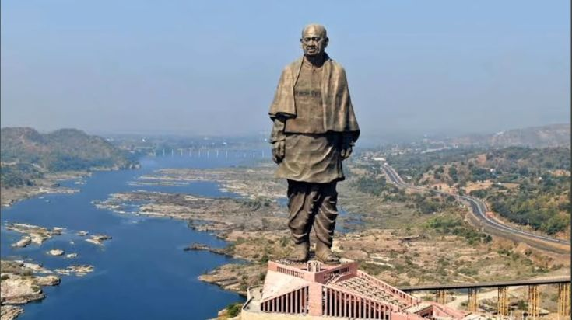
Afternoon proceed for sightseeing tour of Vadodra visitng Statue of Unity – A Monument to National Integration : The Statue of Unity is a monumental tribute to Sardar Vallabhbhai Patel, the revered Iron Man of India and one of the founding fathers of the Republic of India. Conceived to honor his extraordinary contribution to India’s freedom movement and his pivotal role in unifying the nation, the statue stands as a powerful symbol of patriotism, leadership, and national integration. Crafted in bronze, the statue rises to an awe-inspiring height of 182 metres, making it the tallest statue in the world and a landmark of global significance. Its sheer scale and dignified presence command attention while reflecting the strength, resolve, and vision of Sardar Vallabhbhai Patel. The Statue of Unity is located in Gujarat, on Sadhu Bet, a river island on the banks of the River Narmada. Set amidst a dramatic natural landscape, it overlooks the Sardar Sarovar Dam from a distance of approximately 3.2 kilometres, offering visitors a breathtaking blend of engineering excellence, natural beauty, and historical reverence.

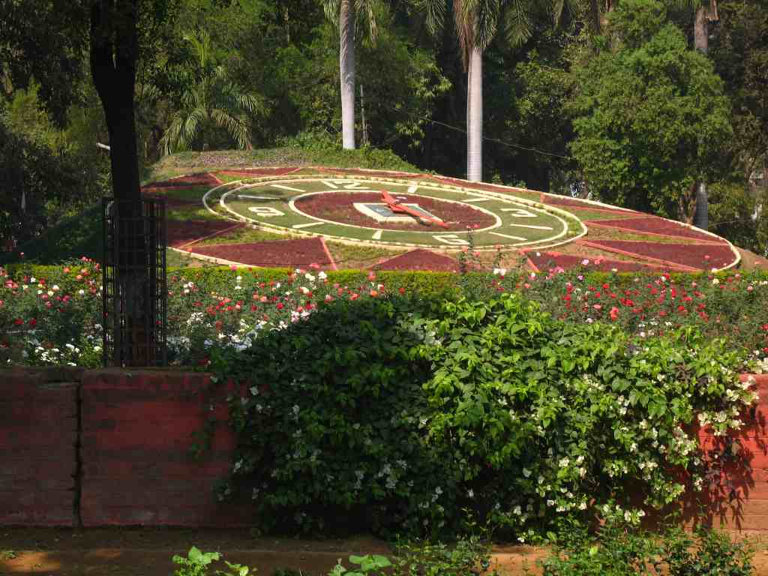
Sayaji Baug (Kamati Baug) – The Green Heart of the City: Located along the banks of the river in the very heart of the city, opposite the bustling railway station and central bus stand, Sayaji Baug is a vast and refreshing urban oasis. Developed in 1879 by Maharaja Sayajirao Gaekwad III, the park was named in his honor and is also popularly known as Kamati Baug. Sprawling across approximately 45 hectares, this beautifully landscaped garden is among the largest public parks in western India and offers a perfect blend of leisure, education, and recreation. Visitors are encouraged to set aside at least half a day to fully explore its diverse attractions, which include two museums, a zoo, a planetarium, a charming flower clock, and an operational toy train that delights visitors of all ages.

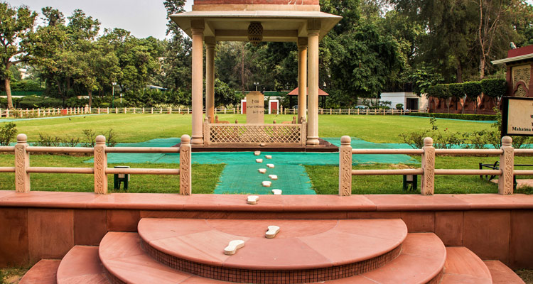
Gandhi Smriti & Birthplace – A Tribute to the Father of the Nation: This serene memorial dedicated to Mahatma Gandhi was established in 1950 and stands as a moving tribute to the life and ideals of the Father of the Nation. Thoughtfully symbolic in design, the structure rises to a height of 79 feet, reflecting Gandhi’s age at the time of his passing, and features 79 candle holders, representing the years of his life. Architectural and spiritual elements from all the world’s major religions have been incorporated, underscoring Gandhi’s universal message of peace, tolerance, and harmony.
Within the memorial complex, visitors can explore a small bookshop and a photographic exhibition showcasing key moments from Gandhi’s life and legacy. Access to the exhibition is via the staircase near the entrance, offering a quiet and reflective experience.

Overnight stay at hotel in Vadodra

DAY 26: | 08 DEC’26| VADODRA – SURAT (150KMS, 02HRS)
Morning after breakfast drive to Surat and drop at wedding place.

DAY 27: | 09 DEC’26 TILL 11 DEC’26| SURAT
Morning after breakfast drive to Surat and drop at wedding place.

DAY 29: | 12 DEC’26| SURAT – MUMBAI (295KMS, 06HRS)
Morning after breakfast drive to Munbai. Upon arrival check in at hotel in Mumbai.

Rest of the day free for shopping / explore surrounding

Overnight stay at hotel in Mumbai

DAY 31: | 13 DEC’26| MUMBAI
Full day transportation at disposal

Overnight stay at hotel in Mumbai

DAY 32: | 14 DEC’26| DEPART MUMBAI (MS KSHMITA)
On time transfer to Mumbai International Airport to board the flight departing at 0235Hrs for the onward destination.

DAY 32: | 14 DEC’26| DEPART MUMBAI (MS KSHMITA MOTHER)
On time transfer to Mumbai International Airport to board the flight departing Mumbai at 1900Hrs for the onward destination.

TOUR COST
CATEGORY | COST PER PERSON
Total cost based for 05 paying pax | INR

City | Hotel | Date | Room | Night
Mumbai | Taj Mahal Palace or similar | 12 – 16 Nov’26 | Luxury Grand City View | 04 Night
Cochin | Taj Malaar or similar | 16 – 17 Nov’26 | Luxury Sea View Room | 01 Night
Munnar | Fragnant Nature or similar | 17 – 19 Nov’26 | Moonlight Bliss Room | 02 Night
Periyar | Spice Village or similar | 19 – 20 Nov’26 | Deluxe Cottage with Private Garden | 01 Night
Kumarakom | Kumarakom Lake Resort or similar | 20 – 21 Nov’26 | Meandering Pool Villa | 01 Night
Varanasi | Taj Ganges or similar | 21 – 23 Nov’26 | Luxury City View Room | 02 Night
Ayodhya | Park Inn By Radisson or similar | 23 – 24 Nov’26 | Deluxe Room | 01 Night
Delhi | The Imperial or similar | 24 – 26 Nov’26 | Heritage Room | 02 Night
Agra | Taj Convetion or similar | 26 – 27 Nov’26 | Deluxe King Bed | 01 night
Jaipur | Raj Palace or similar | 27 – 29 Nov’26 | Historical Room | 02 Night
Jaisalmer | Karwaa Camp | 29 – 30 Nov’26 | Fort Suite Room | 01 Night
Jaisalmer | Taj Gorbandh Palace or similar | 30 Nov – 01 Dec’26 | Luxury Room | 01 Night
Jodhpur | Ajit Bhawan or similar | 01 – 03 Dec’26 | Deluxe Room | 02 Night
Udaipur | Shiv Niwas Palace or similar | 03 – 05 Dec’26 | Terrace Lake Facing Room | 02 night
TOTAL NUMBER OF NIGHTS FOR 05 PAX TILL 05 DEC’26 |  |  |  | 23 NIGHTS

AIR TRAVEL FOR 05 PAX
DATE | SECTOR | FLIGHT | DEPARTURE | ARRIVAL
16 Nov’26 | Mumbai – Cochin | AI 2855 | 1000 Hrs | 1205 Hrs
21 Nov’26 | Cochin – Hyderabad  Hyderabad - Varanasi | 6E 951  6E 6719 | 1340 Hrs  1640 Hrs | 1515 Hrs  1830 Hrs
24 Nov’26 | Ayodhya – Delhi | 6E 6436 | 1400 Hrs | 1525 Hrs
29 Nov’26 | Jaipur – Jaisalmer | 6E 7675 | 0920 Hrs | 1105 Hrs

TOUR COST
CATEGORY | COST PER PERSON
Total cost based for 03 paying pax | INR

City | Hotel | Date | Room | Night
Mumbai | Taj Mahal Palace or similar | 05 – 06 Dec’26 | Luxury Grand City View | 01 Night

AIR TRAVEL FOR 03 PAX
DATE | SECTOR | FLIGHT | DEPARTURE | ARRIVAL
05 Dec’26 | Udaipur – Mumbai | AI 2580 | 1155 Hrs | 1330 Hrs

Our prices include for 3 pax:

Price per person in a 01 Triple room.

Bed and breakfast as per program

Transfers as per itinerary by using Air-Conditioned vehicle.

Government tax (5%).

Our prices do not include:

Beverages.

Any services not mentioned as included, including personal extras such as telephone calls, laundry service, etc.

Entry visa. Visas can be obtained online at: www.indianvisaonline.gov.in

Tips for guides (at the client's discretion).

Travel and cancellation insurance (optional).

TOUR COST
CATEGORY | COST PER PERSON
Total cost based for 02 paying pax | INR

City | Hotel | Date | Room | Night
Ahmedabad | Taj Skyline or similar | 06 – 08 Dec’26 | Luxury Room | 02 Night
Vadodra | Courtyard By Marriott or similar | 08 – 09 Dec’26 | Premium Room | 01 Night
Mumbai | Taj Maha Palace hotel or similar | 12 – 15 Dec’26 | Luxury Grand City View room | 03 Night

